2.6 I can select an appropriate combination of IT tools and devices to carry out collaborative tasks

During my course I have used Git Hub as an online content management system to file my assignments so that they can be easily shared and reviewed by my Tutor. Below is an image of my GitHub account, with repositories set up for each unit I am completing, each containing assignments relevant to the unit named;

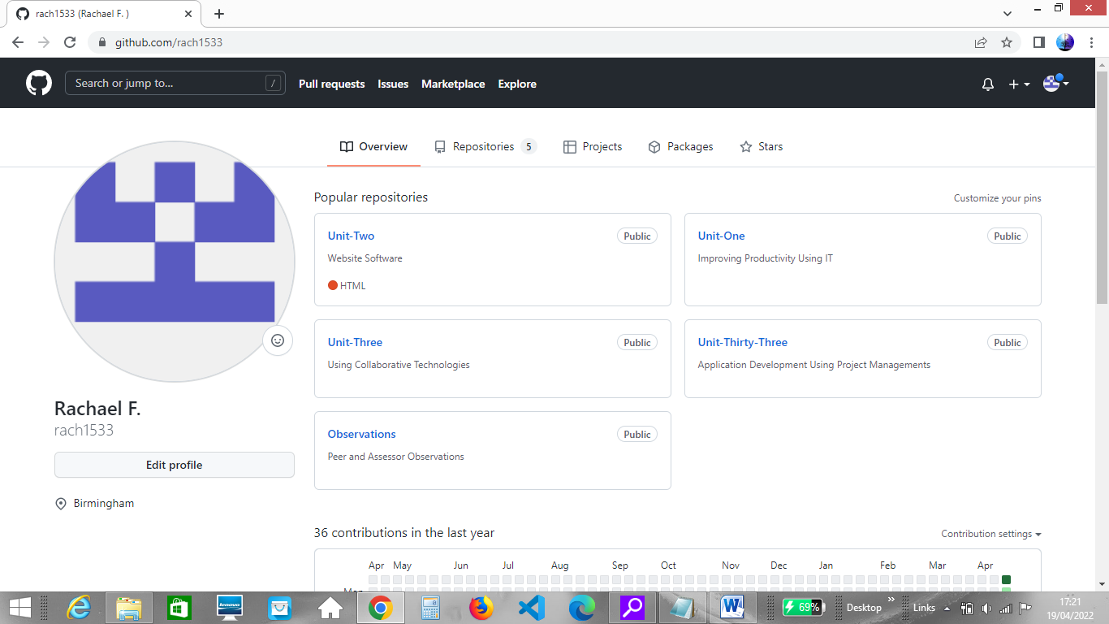

My tutor can easily and securely download or upload my assignments for review and I can also use GitHub to share content with others when working collaboratively. The website is a secure way to upload and share documents and my account can be set to private or public dependent on requirements of the project I am working on.

I have also used my email account during the course to share documents when working collaboratively on assignments with other students. I prefer to use this option when I do not have a lot of files or folders to share and I only need to share with a few recipients. Whilst I can zip folders with documents it can sometimes be time consuming retrieving files from various locations to save into one zipped folder. It is also easy to send a file to the wrong email address

I have used the Adobe Connect meeting app on my mobile phone to attend tutorials for my course. Using my mobile phone device and the app to attend tutorials has meant I have been able to attend tutorials when I have not been able to find a PC or quiet room to work from. Whilst using my app on the mobile phone I am still able to work collaboratively with the tutor and others as I can watch the tutorial live whilst using headphones and contribute using written comments via the chat tool in Adobe Connect.